**Networking**

Class --

**Lecture --**

**Topology**

**.**

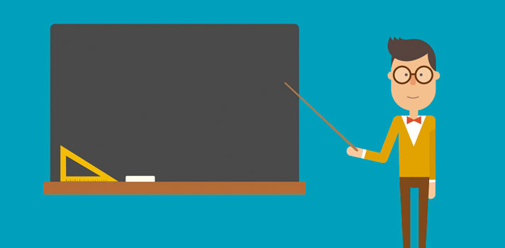

**Lab Objectives:**

* Network Topologies.
* Categories of Topology.
* Mesh.
* Bus.
* Ring.
* Star.
* Tree.
* Hybrid.

**Network Topologies**

***Network topology refers to the shape or the arrangement of the different elements in a computer network (i.e. links and nodes).  Network Topology defines how different nodes in a network are connected to each other and how they communicate is determined by the network's topology. It defines the way different nodes are placed and interconnected with each other. Alternately,* network topology *may describe how the data is transferred between these nodes. There are two types of* network topologies*: physical and logical.***

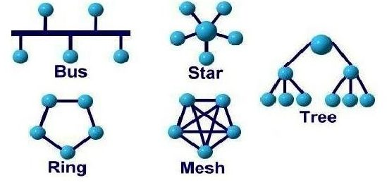

**Categories of topology**

***Network topologies are categorized into the following basic types:***

* ***Mesh***
* ***Bus***
* ***Ring***
* ***Star***
* ***Tree***
* ***Hybrid***

**Mesh Topology**

***It is a point-to-point connection to other nodes or devices. Traffic is carried only between two devices or nodes to which it is connected.***

***Mesh technology comes into two types:***

* ***Full Mesh.***
* ***Partial Mesh.***

***Full Mesh***

***All hosts have a point-to-point connection to every other host in the network. Thus for every new host n(n-1)/2 connections are required.***

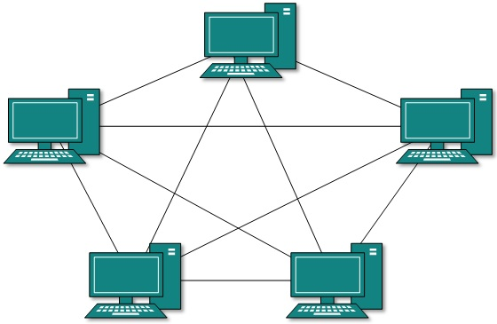

**Partially Mesh Topology**

### *Not all hosts have point-to-point connection to every other host.*

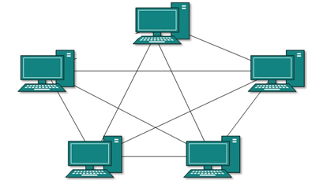

***Advantage & Disadvantage of Mesh topology***

***Advantages:***

* ***It provides the most reliable network structure among all network topologies.***
* ***Even if one of the components fails, data transfer doesn’t get affected.***
* ***Expansion and modification in topology can be done without disrupting other nodes.***

***Disadvantages:***

* ***There are high chances of redundancy in many of the network connections.***
* ***Overall cost of this network is way too high as compared to other network topologies.***

***Note: Set-up and maintenance of this topology is very difficult. Even administration of the network is tough.***

**Bus Topology**

* ***Bus networks use a common backbone to connect all devices.***
* ***All devices are connected to a central cable, called the bus or backbone. Bus networks are relatively inexpensive and easy to install for small networks.***
* ***A device wanting to communicate with another device on the network sends a broadcast message onto the wire that all other devices see, but only the intended recipient actually accepts and processes the message.***

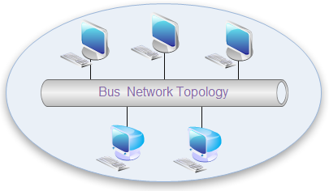

### Advantages and Disadvantages of Bus Topology

***Advantages:***

* ***It is easy to extend bus network.***
* ***Cable length required for this topology is the least compared to other networks.***
* ***Bus topology costs very less.***

***Disadvantages:***

* ***There is a limit on central cable length and number of nodes that can be connected.***
* ***If the main cable (i.e. bus) encounters   some problem, whole network breaks down.***

***It is difficult to detect and troubleshoot fault at individual station.***

**Ring Topology**

***In Ring Topology, all the nodes are connected to each-other in such a way that they make a closed loop. Each workstation is connected to two other components on either side, and it communicates with these two adjacent neighbors. Data travels around the network, in one direction. Sending and receiving of data takes place by the help of TOKEN.*** ***All devices are connected to one another in the shape of a closed loop, so that each device is connected directly to two other devices, one on either side of it.***

***Structure of ring topology:***

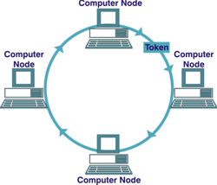

***Advantages and Disadvantages of Ring Topology***

***Advantages:***

* ***Easy to add or remove nodes***
* ***There is no need for network server to control the connectivity between workstations.***
* ***Each computer has equal access to resources.***

***Disadvantages:***

* ***If one workstation or port goes down, the entire network gets affected.***
* ***Network is highly dependent on the wire which connects different components.***
* ***Each packet of data must pass through all the computers between source and destination. This makes it slower***

**Star Topology**

* ***In Star topology, all the components of network are connected to the central device called “hub” which may be a hub, a router or a switch.***
* ***All devices are connected to a central hub. Star networks are relatively easy to install and manage, but bottlenecks can occur because all data must pass through the hub***

***Structure of star topology:***

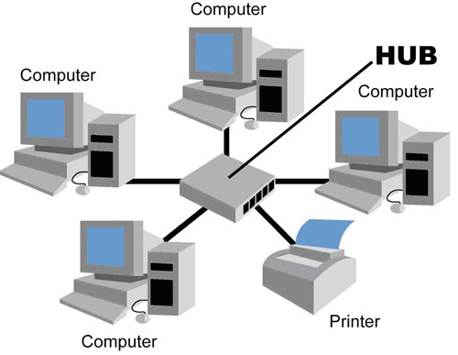

***Advantages and Disadvantages of Star Topology***

***Advantages:***

* ***Centralized management. It helps in monitoring the network.***
* ***Failure of one node or link doesn’t affect the rest of network.***
* ***Easy to connect new nodes or devices.***

***Disadvantages:***

* ***Too much dependency on central device has its own drawbacks.***
* ***The use of hub, a router or a switch as central device increases the overall cost of the network.***
* ***Performance and as well number of nodes which can be added in such topology is depended on capacity of central device.***

**Tree Topology**

* ***It is also called Expanded Star Topology.***
* ***Tree Topology integrates the characteristics of Star and Bus Topology.***
* ***In Tree Topology, the number of Star networks are connected using Bus.***
* ***This main cable seems like a main stem of a tree, and other star networks as the branches.***

***Structure of tree topology:***

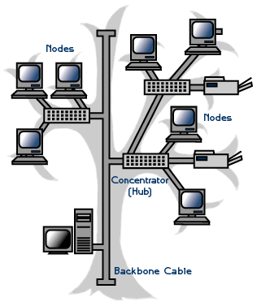

***Advantages and Disadvantages of Tree Topology***

***Advantages:***

* ***Expansion of Network is possible and easy.***
* ***If one segment is damaged, other segments are not affected.***
* ***Error detection and correction is easy.***

***Disadvantages:***

* ***Relies heavily on the main bus cable, if it breaks whole network is crippled.***
* ***Ability of work of cable of the network depends on the type of cable used.***

***As more and more nodes and segments are added, the maintenance becomes difficult.***

**Hybrid Topology**

***This type of topology we integrate two or more different topologies to form a resultant topology which has good points(as well as weaknesses) of all the constituent basic topologies rather than having characteristics of one specific topology.***

***Structure of hybrid topology:***

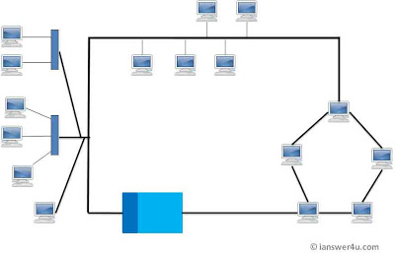

***Advantages and Disadvantages of Hybrid Topology***

***Advantages:***

* ***Reliable: Unlike other networks, fault detection and troubleshooting is easy in this type of topology.***
* ***Scalable: It’s easy to increase the size of network by adding new components, without disturbing existing architecture.***
* ***Effective: Hybrid topology is the combination of two or more topologies, so we can design it in such a way that when what is needed.***

***Disadvantages:***

* ***Complexity of Design***
* ***Costly Hub/Switch or routers***
* ***As hybrid architectures are usually larger in scale, they require a lot of cables, cooling systems, sophisticate network devices, etc. So it is costly.***



***End Of this slide***